Program 2
CSC 1310, Spring 2026
SORTING ALGORITHM COMPARISON

Objective of this assignment
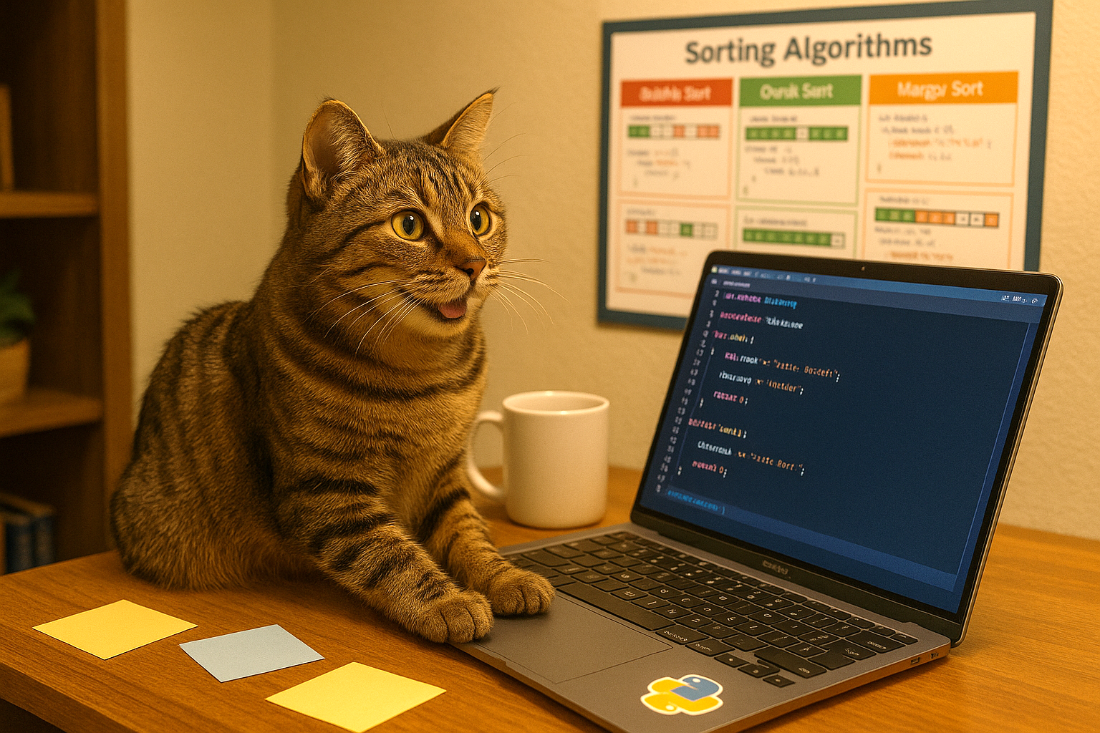
The primary goal & challenge of this assignment is not just learning to write code but in learning about sort algorithms, comparing algorithm efficiencies, and learning to apply parallel programming using OpenMP.
Modern software is built to run fast and efficiently on multi-core systems, and that means parallel programming is no longer optional—it's essential. Learning it early gives you a serious edge, making you more competitive, job-ready, and prepared to solve real-world problems at scale.
Image created with ChatGPT 4.0 https://chatgpt.com/s/m_6868273bc4b48191978c1a469a4cb100

TWO DUE DATES!
- Part 1: The working program code is due on 3/3/2026
- Part 2: The testing documentation document is due on 3/5/2026

IMPORTANT RULES YOU MUST FOLLOW SO YOU DO NOT GET A ZERO
Failure to follow the policies below will result in a zero of some or all sections of the grade rubric.

You may not use the following in your code:
- while(true) or while(1)
- Goto statements
- Recursively calling the main function
- exit()
- ternary operators (any syntax requiring a ‘?’)

Generative AI policy for Program 2 Assignment
- You may use generative AI to help you with troubleshooting the code and help with answering questions in the documentation. However, if you do, you must share your entire generative AI conversation. If you have OpenAI’s ChatGPT or Claude Sonnet, you can share a public link to your chat by clicking “Share” in the top right, creating the link, and then put the link in a comment in your source file(s).
- You may NOT copy and paste any part of the programming assignment instructions or sample output, but you may upload your code to aid in troubleshooting.
- You may NOT ask generative AI to create functions or any code for you. This will be considered academic misconduct for this assignment.
- You may not show more than 1 to 2 lines of code to another person (parent, other students – even if they are not in our class) who is not a TA or instructor. This will be considered academic misconduct for this assignment.
- If you get ideas on how to write a portion of your code from somewhere other than your brain, provided CSC 1310 materials, or CSC 1310 TAs/instructors, you must CITE YOUR SOURCE in a comment in that section of your code. You still must be able to explain what the code is doing.

Part 1: The program

Program OVERVIEW
You will implement multiple sorting algorithms and integrate parallelization using OpenMP. Some portions of the code, such as reading input from text files, have already been provided to you. The assignment involves:
- Implementing sorting functions in both sequential and parallel versions.
- Testing your implementations on integer and string data.
- Measuring and analyzing the performance of different algorithms under various conditions.
- Documenting your findings based on experimental results.

How to compile

Windows
If you are using the Windows operating system and the GCC compiler (like MinGW), then it already supports OpenMP by default. You only need to include –fopenmp when compiling and include the correct libraries.

Compiling C++ with OpenMP
g++ -Wall -fopenmp program2.cpp -o prog2

Run Your Program
prog2

Mac
Using OpenMP on a Mac requires a bit of setup because Apple’s default clang compiler does not support OpenMP by default. You’ll need to install a version of the compiler that does support OpenMP, like GCC via Homebrew.

Is Homebrew already Installed?
Open Terminal and run
which –s brew
If Homebrew is installed, you will see the full path to the brew executable, usually:
/opt/homebrew/bin/brew (if on Apple Silicon Macs) or
/usr/local/bin/brew (if on Intel Macs)
If Homebrew is not installed, you will see:
brew not found

Install Homebrew (if it isn’t already installed)
In the Terminal, run (all on one line):
/bin/bash -c "$(curl -fsSL https://raw.githubusercontent.com/Homebrew/install/HEAD/install.sh)"

Install GCC (which supports OpenMP)
brew install gcc
This installs a GCC version like gcc-14 or later, depending on the current release.

Check the GCC version
ls /opt/homebrew/bin | grep “g++” (if on Apple Silicon Macs) or
ls /usr/local/bin | grep “g++” (if on Intel Macs)

Compiling C++ with OpenMP
If your Homebrew installed GCC 14, the command will be:
g++-14 –fopenmp -Wall program2.cpp –o prog2
Replace g++-14 with the version Homebrew installed (gcc-13, gcc-15, etc.)

Run your program
./run

Given Code
- program2.cpp
- program2.h
- numsSmall.txt – use this text file along with wordsSmall.txt to test your sorting functions to make sure they actually sort correctly
- wordsSmall.txt– use this text file along with numsSmall.txt to test your sorting functions to make sure they actually sort correctly
- numsLarge.txt
- wordsLarge.txt

Specifications

Given Code
In program2.cpp, you are given all the #includes, part of the main function, the readFromFile() function, the printVector() function, and the scramble() function.

main function
You are given some of this function and then there are detailed comments describing what you should add in this function.

Prototype the Functions as you implement them
In the program2.h file, write function prototypes for the functions listed below. All these functions should be template functions because they need to be able to be used with both integer vectors and string vectors.
- bubbleSort: The input will be a vector
- parallelBubbleSort: The input will be a vector
- mergeSort: The input will be a vector, the low index and the high index.
- parallelMergeSort: The input will be a vector, the left index, the right index, and a depth integer variable for parallelization
- merge: The input will be the vector, the left index, the right index, and the middle index. This function will be called by both mergeSort and parallelMergeSort.

Bubble Sort
For the bubbleSort() function, you will implement the Bubble Sort algorithm as shown in class and in sample code.

Parallel “Bubble Sort”
Technically, once you alter the Bubble Sort algorithm to be able to run in parallel, it is really no longer bubble sort but instead is the "Odd Even Transposition Sort" or "Brick Sort". In this algorithm we alternately swap the even items with their next item for one pass, and then the odd items with their next time for the next pass. It is similar to another sort algorithm called the shaker sort. This algorithm lends itself well to parallelization because all of the compare-and-swap operations in each pass could theoretically be performed at once on a vector using OpenMP to accelerate the process by taking advantage of multiple CPU threads.
- Before writing code, check out this visualization first: https://sortvisualizer.com/oddevensort/ (turn sound up!)
Notice that elements are still “bubbling up” – but in a different way.
- You can read more about the odd-even sort here: https://en.wikipedia.org/wiki/Odd%E2%80%93even_sort
- And you can see another visualization (not as fun one, though) and see sample (Java) code here: https://algostructure.com/sorting/oddevensort.php
Notice in the Java code example from the last website I provided above that there are TWO for loops – one for odd indexes and the other for even indexes. Both of these for loops are nested in a while loop.
To set up this algorithm to run in parallel, you will have to have define a parallel region INSIDE the while loop
#pragma omp parallel (and enclose the parallel region in curly braces). The parallel region should contain the two for loops.
However, just setting up the parallel region isn’t enough to make the for loops be able to run through the vector elements in parallel.
You will need to use #pragma omp for reduction(||:swapped) above each for loop. The “swapped” part of this #pragma is just the Boolean variable that I used in order to exit the loop if no swaps were made in the last iteration of the while loop. In the Java code in the algostructure.com website, they used the variable “sorted”. This #pragma directive uses OpenMP's logical OR (||) reduction which causes each thread to get a private copy of the swapped variable. Each thread will work independently and update its own private copy. At the end of the parallel region (end of the for loop), OpenMP combines all the private copies using the operator specified (in this case, || = logical OR) and this is what we want because if any thread sets its swapped to true, the final shared swapped becomes true and means that we aren’t done sorting the vector so keep working. The logical OR reduction prevents every thread from modifying the shared variable directly, which would cause the following:
- Race conditions (multiple threads trying to write to swapped at the same time)
- False sharing and cache coherence issues
- Overhead from synchronizing writes to shared memory (this slows things down and creates unpredictable behavior)

Merge Sort
For the mergeSort() function, you will implement the Merge Sort algorithm as shown in class and example code, which means you will also need a merge() function. The merge() function is used by both the mergeSort() function and the parallelMergeSort() function.

Parallel Merge Sort
When you call the parallelMergeSort() function from the main function, you will be sending a fourth argument that represents the depth of recursion, which begins at zero. The depth is required in the parallel version of this algorithm because depth controls how deep the parallel recursion goes to prevent creating too many threads, which would end up slowing down runtime instead of speeding up!
After calculating the middle index of the current range to split the vector into two halves, you will then need an if statement to check if the depth is below 4. This is because if we are not too deep in the recursion tree, we allow parallelism. This keeps thread creation under control.
If the depth is below 4, then you will have an OpenMP directive that will tell OpenMP to run independent code sections in parallel using multiple threads. Refer to the OpenMP slides on “Task Parallelism with Parallel Sections”. Each recursive call to parallelMergeSort() should be preceded by an OpenMP directive that will define an OpenMP section. This means that the left half of the vector (from left to mid) will be in a new thread (section) and the right half of the vector (from mid+1 to right) will also be in a new thread (section).
If the depth is at 4 or above, then just do the recursive calls to parallelMergeSort() without parallelizing them.

Incremental Programming & Testing
Only implement ONE FUNCTION AT A TIME and then test that function. Use the smaller text files and call the printVector() function to test to make sure the sort algorithm is working. Then, remove the call to printVector() and test the function with the larger files.

Part 2: DOCUMENTATION
In a Word document named program2_documentation.docx, you must document going through the following steps to test your code after you know it is working properly. Read incremental programming & testing above!
- First, make sure to disable anti-virus on your computer and stop/close all unnecessary programs from running (close out Teams, Outlook, Discord, etc.). You may keep Microsoft Word or Google Docs open to document the steps below.
- Run Sample Output 1 (shown in Sample Output section in this document).
- Take a screenshot of your sample output 1 results and paste into the document.
- Analyze your results and write answers to the questions below in the document.
  - Why do you think you got the results that you got?
  - What algorithm was the fastest out of the algorithms you implemented?
  - What algorithm was the slowest?
  - Was the parallel bubble sort algorithm faster than the serial bubble sort algorithm?
  - How does your results compare to the sample output provided?
- Run Sample Output 2 (shown in next section), including the input validation.
- Take a screenshot of your sample output 2 results and paste into the document.
- Analyze your results.
  - Why do you think you got the results that you got?
  - How does it compare to the sample output provided?
- Run Sample Output 3 (shown in next section).
- Take a screenshot of your sample output 3 results and paste into the document.
- Analyze your results.
  - Why do you think you got the results that you got?
  - How does it compare to the sample output provided?
- Try several different numbers of threads and figure out what number of threads gave you the quickest runtime for the parallel algorithms. Provide a screenshot of the quickest runtime of parallel bubble sort.
- You may have noticed that when you increase the number of threads that parallel bubble sort slows down significantly, but parallel merge sort does not. Why is that? (Note: you may use ChatGPT or similar GenAI to help you with this answer if needed).

Program Report (to be submitted with part 2)
Fill out this program report and take a screenshot of the confirmation page after submitting and name it prog2report. This is similar to the lab reports but for programming assignments instead (I forgot to do it for program 1).
Program Report Link: https://tntech.co1.qualtrics.com/jfe/form/SV_5vhCYdoB1bhJXM2

Submission instructions
Make sure your source and header file have a comment block at the top where you have put your names, the date, and purpose of program.
Create a folder named yourTTUusername. Then, create two subfolders under that one named Part 1 and Part 2.
See below to see which files should go in each folder. Zip the parent (your username) folder (.zip) and upload it to ilearn for both parts. Note that it is expected that the Part 2 folder may be empty in the part 1 assignment submission but for the Part 2 assignment submission, both Part 1 and Part 2 folders should have files. Ensure you have all these files in your submission by downloading them from ilearn after you submit them and checking the folder!
- yourTTUusername folder (zip file of this parent folder submitted for both parts)
  - Part 1 folder (due 3/3/26)
    - program2.cpp
    - program2.h
    - all the provided text files
  - Part 2 folder (due 3/5/26)
    - program2_documentation.docx
    - prog2report

Sample Output
The number of processors is machine dependent as well as the time it will take to run all these algorithms. Therefore, you will likely get different results then what you see in the sample output unless your computer is very similar to Mrs. Crockett’s computer running similar processes in the background. Most laptops have 8 or 10 processors, not 20.

Sample Output 1 – Using 4 Threads
User input highlighted in yellow.

How many threads do you want OpenMP to use? (Enter 1-500) 4

Number of Threads Used: 4
Number of Processors: 20

What is the name of the string (word) text file?
(wordsSmall.txt or wordsLarge.txt)
FILENAME: wordsLarge.txt

What is the name of the string (word) text file?
(numsSmall.txt or numsLarge.txt)
FILENAME: numsLarge.txt
SIZE of words: 31100
SIZE of nums: 37084

<parallel/algorithm> library sort(int): 0.007 seconds
<parallel/algorithm> library sort(words): 0.008 seconds

Bubble Sort(int): 17.069 seconds
Bubble Sort(string): 23.595 seconds

Parallel Bubble Sort(int): 1.789 seconds
Parallel Bubble Sort(string): 5.549 seconds

Merge Sort(int): 0.017 seconds
Merge Sort(string): 0.038 seconds

Parallel Merge Sort(int): 0.009 seconds
Parallel Merge Sort(string): 0.02 seconds

Sample Output 2 – showing input validation and using 20 threads

How many threads do you want OpenMP to use? (Enter 1-500) twenty

Oops! You didn't enter a number!
Enter a number 1 - 500: duh

Oops! You didn't enter a number!
Enter a number 1 - 500: -489

Oops! You didn't enter a number between 1-500!
Enter a number 1 - 500: 20

Number of Threads Used: 20
Number of Processors: 20

What is the name of the string (word) text file?
(wordsSmall.txt or wordsLarge.txt)
FILENAME: wordsLarge.txt

What is the name of the string (word) text file?
(numsSmall.txt or numsLarge.txt)
FILENAME: numsLarge.txt
SIZE of words: 31100
SIZE of nums: 37084

<parallel/algorithm> library sort(int): 0.008 seconds
<parallel/algorithm> library sort(words): 0.006 seconds

Bubble Sort(int): 17.129 seconds
Bubble Sort(string): 23.559 seconds

Parallel Bubble Sort(int): 3.738 seconds
Parallel Bubble Sort(string): 5.501 seconds

Merge Sort(int): 0.021 seconds
Merge Sort(string): 0.042 seconds

Parallel Merge Sort(int): 0.009 seconds
Parallel Merge Sort(string): 0.022 seconds

SAMPLE OUTPUT 3 – Using 500 Threads

How many threads do you want OpenMP to use? (Enter 1-500) 500

Number of Threads Used: 500
Number of Processors: 20

What is the name of the string (word) text file?
(wordsSmall.txt or wordsLarge.txt)
FILENAME: wordsLarge.txt

What is the name of the string (word) text file?
(numsSmall.txt or numsLarge.txt)
FILENAME: numsLarge.txt
SIZE of words: 31100
SIZE of nums: 37084

<parallel/algorithm> library sort(int): 0.115 seconds
<parallel/algorithm> library sort(words): 0.1 seconds
The parallel version of bubble sort took over 1 full minute to run!
Bubble Sort(int): 16.887 seconds
Bubble Sort(string): 23.359 seconds

Parallel Bubble Sort(int): 87.126 seconds
Parallel Bubble Sort(string): 79.342 seconds

Merge Sort(int): 0.018 seconds
Merge Sort(string): 0.039 seconds

Parallel Merge Sort(int): 0.009 seconds
Why do you think increasing the number of threads didn’t seem to affect parallel merge sort?
Parallel Merge Sort(string): 0.022 seconds

